EXPERIMENT 5

5.1.1Leap Year Checker

Algorithm:
Step1: Start.
Step2: Read the value of input year.
Step3: check if the year is divisible by 4.
Step4 : If yes:
Print ‘Leap Year’
Else:
Print ‘Not a leap year’
Step5: Stop.

Flowchart:
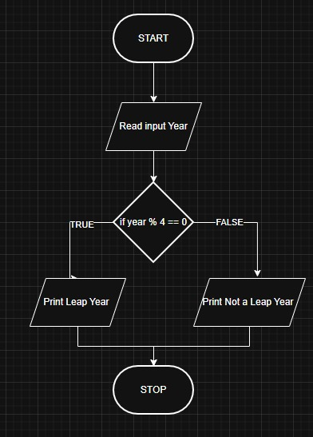

Execution:
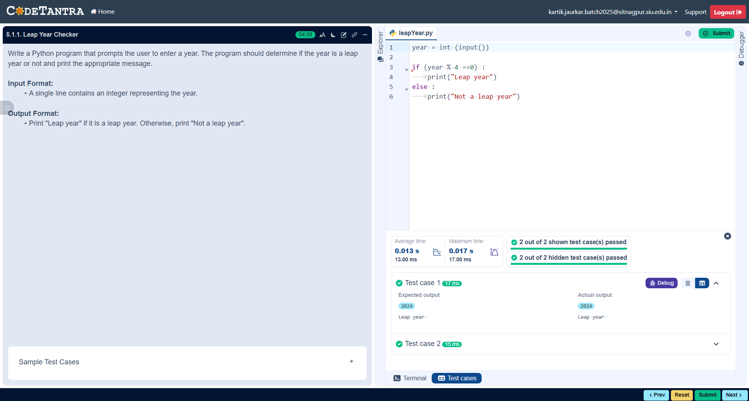

5.1.2 Student Grade Based on Aggregate

Algorithm:
Step1: Start.
Step2: Input 4 integers:m1, m2, m3, m4.
Step3: Calculate Total.
Step4: Print “total”.
Step5: Calculate Percentage.
Step6: Print “percentage”.
Step7: Check percentage:
- If percentage > 75
Print "Distinction"
- Else if percentage >= 60 and < 75
Print "First Division"
- Else if percentage >= 50 and < 60
Print "Second Division"
- Else if percentage >= 40 and < 50
Print "Third Division"
- Else
Print "Fail"
Step8: Stop.

Flowchart:
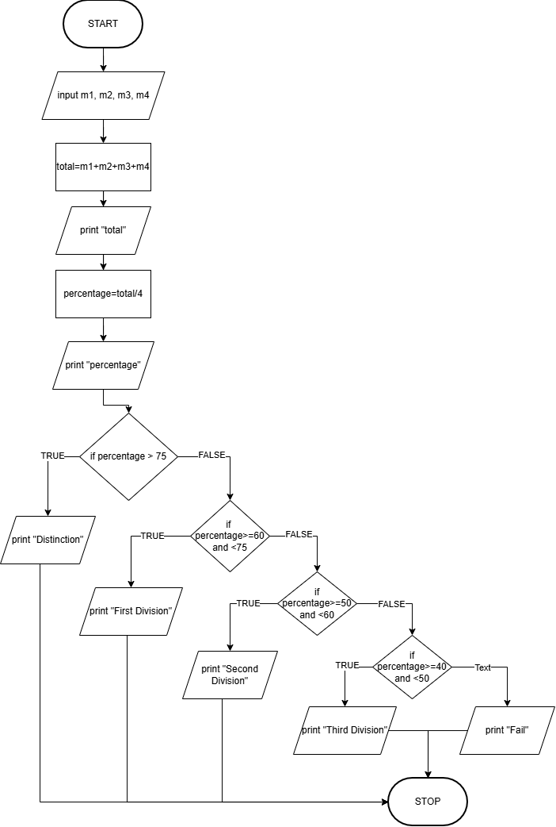

Execution:
